**ID: hrajranj**

**Day1 – 14th May 2025**

**SDLC:**

**Tasks:**

1. **What is SDLC?**

Answer: SDLC stands for Software Development Life Cycle. It is a structured framework used in software development which includes the entire process of building it. It includes planning, designing, developing, testing, deploying and maintenance to ensure high-quality products which meets user expectations.

1. **Why is SDLC?**

Answer:

1. It gives a clear and structure planning for software development.
2. Helps in better managing of the projects.
3. Helps in team collaborations.
4. Deadlines can be met easily with proper SDLC planning.
5. It helps in overall successful building of a product to meet the client requirements along with timely feedbacks.
6. **What are the different steps in SDLC?**

Answer:

1. Planning
2. Requirement analysis
3. Designing
4. Developing
5. Testing
6. Deployment
7. Maintenance
8. **What are the different SDLC models?**

List them, description – 4 lines min and with an image

Answer:

1. Waterfall model - This is a traditional model where each stage of SDLC has to be completed before moving to the next one.
2. V-model – This includes testing at each stage of SDLC.
3. Iterative model – In this model, the project is broken into smaller chunks of iterations, where each iteration delivers a working software.
4. Spiral model – It is a combination of iterative and waterfall model approach. Project goes through loops of certain iterations again and again.
5. Agile – It is similar to iterative model which has incremental approach, it focuses on flexibility and collaboration for rapidly changing environment in the project.
6. Incremental model – In this model, project is divide into several chunks/increments and the same phases are repeated and followed in each increment.
7. RAD model – Rapid application development model. It is similar to waterfall and iterative model used in small developments.
8. Devops – This combines agile approach with devops, focusing collaboration of developers’ team with operations team.

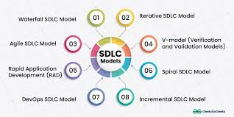

1. **What are the different network types?**

Answer: Personal Area Networks (PANs), Local Area Networks (LANs), Wireless Local Area Networks (WLANs), Metropolitan Area Networks (MANs), Wide Area Networks (WANs), and Virtual Private Networks (VPNs).

1. **What are the types of servers? Make a list and write a 2 to 3 liners about it.**

Answer:

1. Web servers: Hosts web applications and websites where users can access them via web browsers.
2. Mail servers: sending and receiving of emails.
3. Database servers: To store data in structured format where applications can access it.
4. Application servers: To host software applications, where users can access them via devices.
5. File servers: Store files where users can access and share them.
6. Print servers: printing services
7. DNA servers: Translates domain names into IP addresses, where users can access websites.
8. Proxy Servers: Intermediates between clients and other servers.
9. Virtual Servers: These provide virtualized computing resources, where multiple servers can run on a single server.
10. **This is Verbal task**

**What do you know about DNS?**

The Domain Name System (DNS) is a system that converts website domain names into numerical values (IP address) so they can be found and loaded into your web browser. It is essentially the phonebook of the internet

1. **What is TCP and UDP? What is the difference?**

Answer: Transmission control protocol and User datagram protocol are 2 common protocols of the transport layer protocol used for data transmission over the network.

Differences:

TCP - Connection oriented, reliable, slower, guarantees data delivery, error-checking, and data ordering

UDP – Connection-less, unreliable, faster, doesn't guarantee data delivery, order, or error detection

1. **What do you know about mac address? What is the difference between Mac address and IP address?**

Answer: A MAC address is a hardware address (unique 12-digit hexadecimal number) assigned to a device by the manufacturer and is used for local network communication. It is a unique identifier for a device on a local network.

IP address is a software address (unique numerical label) assigned by a network administrator used for global network communication. It allows devices to communicate with each other.

1. **This is both Written and Oral. You guys need to answer this qn and share your**

**screen and explain to us your understandings.**

**What is OSI model?**

Answer:

The OSI (Open Systems Interconnection) Model is a set of rules that explains how different computer systems communicate over a network. It consists of 7 layers and each layer has specific functions and responsibilities. This layered approach makes it easier for different devices and technologies to work together. It provides a clear structure for data transmission and managing network issues. It is widely used as a reference to understand how network systems function.

There are 7 layers in the OSI Model:

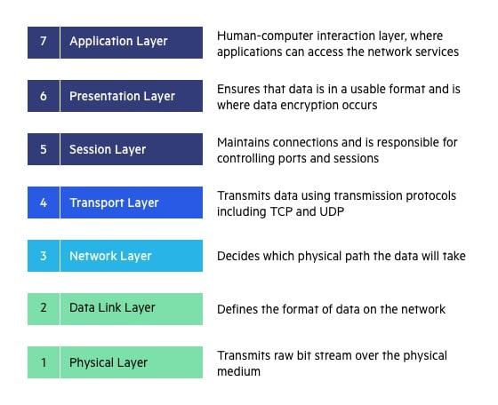

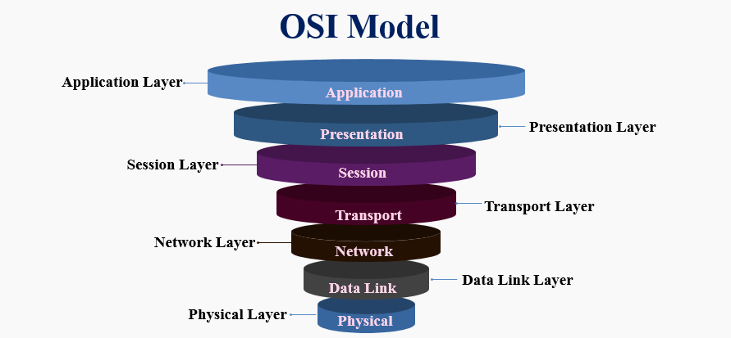

* Physical Layer: The lowest layer of the OSI reference model is the Physical Layer. It is responsible for the actual physical connection between the devices. The physical layer contains information in the form of bits.
* Data Link Layer: The data link layer is responsible for the node-to-node delivery of the message. The main function of this layer is to make sure data transfer is error-free from one node to another.
* Network Layer: The network layer works for the transmission of data from one host to the other located in different networks. It also takes care of packet routing i.e., selection of the shortest path to transmit the packet, from the number of routes available.
* Transport Layer: The transport layer provides services to the application layer and takes services from the network layer. The data in the transport layer is referred to as Segments. It is responsible for the end-to-end delivery of the complete message.

* Session Layer: Session Layer in the OSI Model is responsible for the establishment of connections, management of connections, terminations of sessions between two devices. It also provides authentication and security.

* Presentation Layer: The presentation layer is also called the Translation layer. The data from the application layer is extracted here and manipulated as per the required format to transmit over the network.
* Application Layer: At the very top of the OSI Reference Model, we find the Application layer which is implemented by the network applications. These applications produce the data to be transferred over the network.

1. **What is an IPv4 address? What are the different classes of IPv4?**

Answer: An IPv4 address is a numerical label assigned to each device connected to a network, using the Internet Protocol version 4. It uses a 32-bit address scheme. IPv4 addresses are typically displayed in decimal format, divided into four octets separated by dots.

IPv4 addresses are divided into five classes: A, B, C, D, and E, each with a specific purpose and

range of addresses.

Class A: First Octet Value 0-126.

Class B: First Octet Value 128-191.

Class C: First Octet Value 192-233.

Class D: First Octet Value 224-239.

Class E: First Octet Value 240-255.

1. **What are the advantages of using VPN?**

Answer: A VPN (Virtual Private Network) creates a private network connection between devices through the internet. it works by creating an encrypted tunnel between our device and a remote server.

Advantages:

- Privacy Protection

- Security on Public Networks

- Prevent Data Throttling

- Accessing Remote Work Resources

- Safer Online Transactions

1. **What are the types of VPN?**

Types of VPN Give 1 liner for each Access VPN Site to site vpn Intranet VPN Extranet VPN

Answer:

Access VPN: It allows users to connect to a network remotely.

Site to Site VPN: It allows to connect two or more distinct networks.

Intranet VPN: It allows to connect multiple sites belonging to the same institution.

Extranet VPN: It allows to connect to different organizations, enabling secure data transfer and resource sharing between their networks.

1. **Node and link**
2. **Topology means**
3. **What are the different types of networks topology?**

Answer:

Mesh Topology: Each device is connected to another device through a dedicated channel.

Star Topology: All devices are connected to a single hub through a cable.

Bus Topology: Multi-point connection where each computer and network device is connected to a single cable.

Ring Topology: It connects between 2 neighboring devices forming a ring structure.

Tree Topology: It has hierarchical flow of data where various secondary hubs are connected to a central hub.

Point to Point Topology: Communication between 2 nodes, one is the sender and the other is receiver.

Hybrid Topology: Combination of all types of topologies where nodes are ready to take any form.

1. **What is extended bus topology? its Tree Topology.**
2. **What is the difference between router and gateway?**

Answer**:** A Router is a device or hardware that manages and forwards data packets between networks. A router determines the destination or the target IP address of the packet.

Gateway is a hardware or a device that acts as a gate among different networks or systems. It also acts as a node that serves as an entry point for various other networks.

1. **SMTP**

Answer: **Simple Mail Transfer Protocol (SMTP)** is an application layer protocol that defines the rules for how email clients and servers communicate.

To send an email, the client opens a TCP connection to the SMTP server. The server, then initiates the connection as soon as it detects a client. Once the TCP connection is established, the client sends the email across the connection ensuring that our emails get sent and received successfully across the internet.

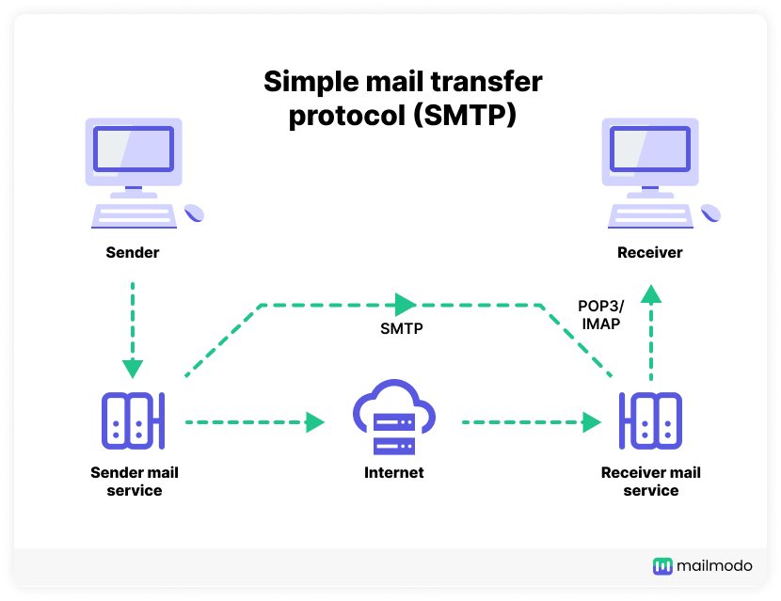

1. **What is the difference between OSI and TCP/IP model?**

**Answer: These are two frameworks used to understand how data moves through networks.**

**OSI Model:**

**OSI stands for Open Systems Interconnection. It has 7 layers: Physical layer, Data Link layer, Network layer, Transport layer, Session layer, Presentation layer, and Application layer. It is vertically approached.** Delivery of the package is guaranteed in OSI Model. It is protocol-independent.

**TCP/IP Model:**

**TCP/IP stands for Transmission Control Protocol/Internet Protocol. It has 4 layers: Physical layer, Network layer, Transport layer, and Application layer. It is horizontally approached.** Delivery of the package is not guaranteed in TCP/IP Model. It is protocol-dependent.

1. **http and https**
2. **Difference between High Level Design (HLD) and Low Level Design (LLD)**

**Answer:**

**HLD refers to the overall system design that provides an overview of the system’s architecture.**

**LLD** refers to component-level design process which **focuses on the details of individual components and modules.**

1. **What is SRS (Software Requirement Specification)? explain in 3 to 4 lines with a diagram.**

**Answer:** Software requirements specification (SRS) isa detailed description/document that describes the requirements for a software system to be developed with its functional and non-functional requirements. It is a document that describes what the software will do and how it will be expected to perform. The SRS ensures that all stakeholders have a clear understanding of the software's intended functionality, features, and non-functional requirements like performance and security.

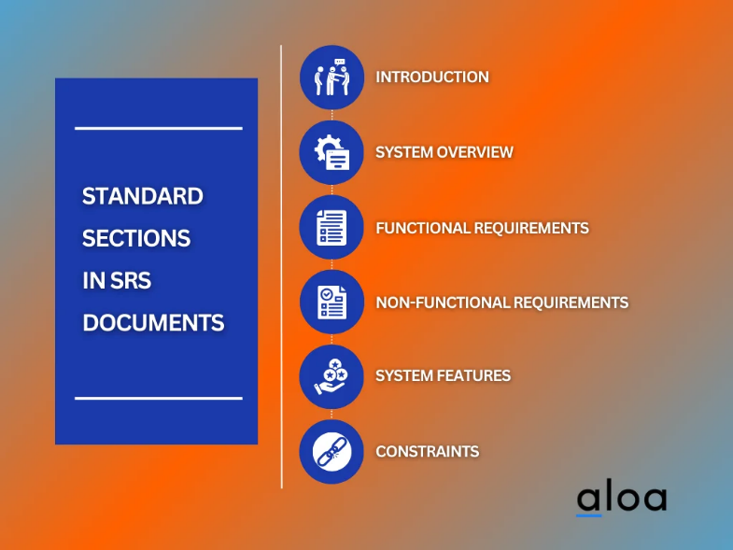

**SDLC MCQ**

1.

A feasibility study using the SDLC model is conducted to

determine whether or not the project is technically possible

determine whether the proposal is financially viable

Both a and b

None of the above

2.

A well-documented life cycle model aids in the detection of what during the development phase?

Inconsistencies

Redundancies

Omission

All of the above

3.

How many lines of code does the Build & Fix Model suit for programming exercises?

100-200

300-400

600-700

Above 800+

4.

In which life cycle does regression testing play a significant role?

Waterfall model

V model

Iterative model

All of the above

5.

What determines if the project should go forward?

feasibility assessment

opportunity identification

system evaluation

program specification

6.

What is the most significant disadvantage of employing the RAD Model?

Developers/designers that are highly specialized and skilled are required.

Component reusability is improved.

Encourages client/customer input.

Increases component reusability.

7.

Which of the following developmental models is incremental?

Prototyping, V model, Agile

Prototyping, RAD, Agile, RUP

Prototyping, V model, RAD, Agile, RUP

All of the above

8.

Which of the following is an Agile development characteristic?

Shared code ownership

Test-Driven Development

Implement the simplest solution to meet today's problem

Continual feedback from customer

All of the above

9.

Which of the following steps in the SDLC framework are valid?

Requirement Gathering

Software Design

System Analysis

All of the above

10.

Who is in charge of system development, staffing, budgeting, and reporting, as well as ensuring that deadlines are met?

Project managers

Network engineers

Graphic designers

Systems analysts